**Date:** 21-11-2024 **Aspirian Name:** JEEVA ARAVINTH J V

**AZURE Account Creation**

**STEP 1:** Create an Account

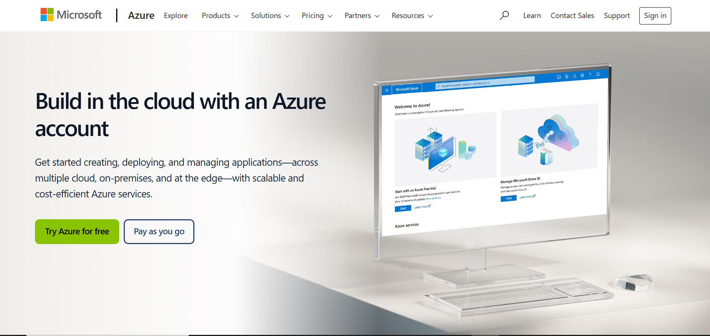

**STEP 2:** Sign in Process 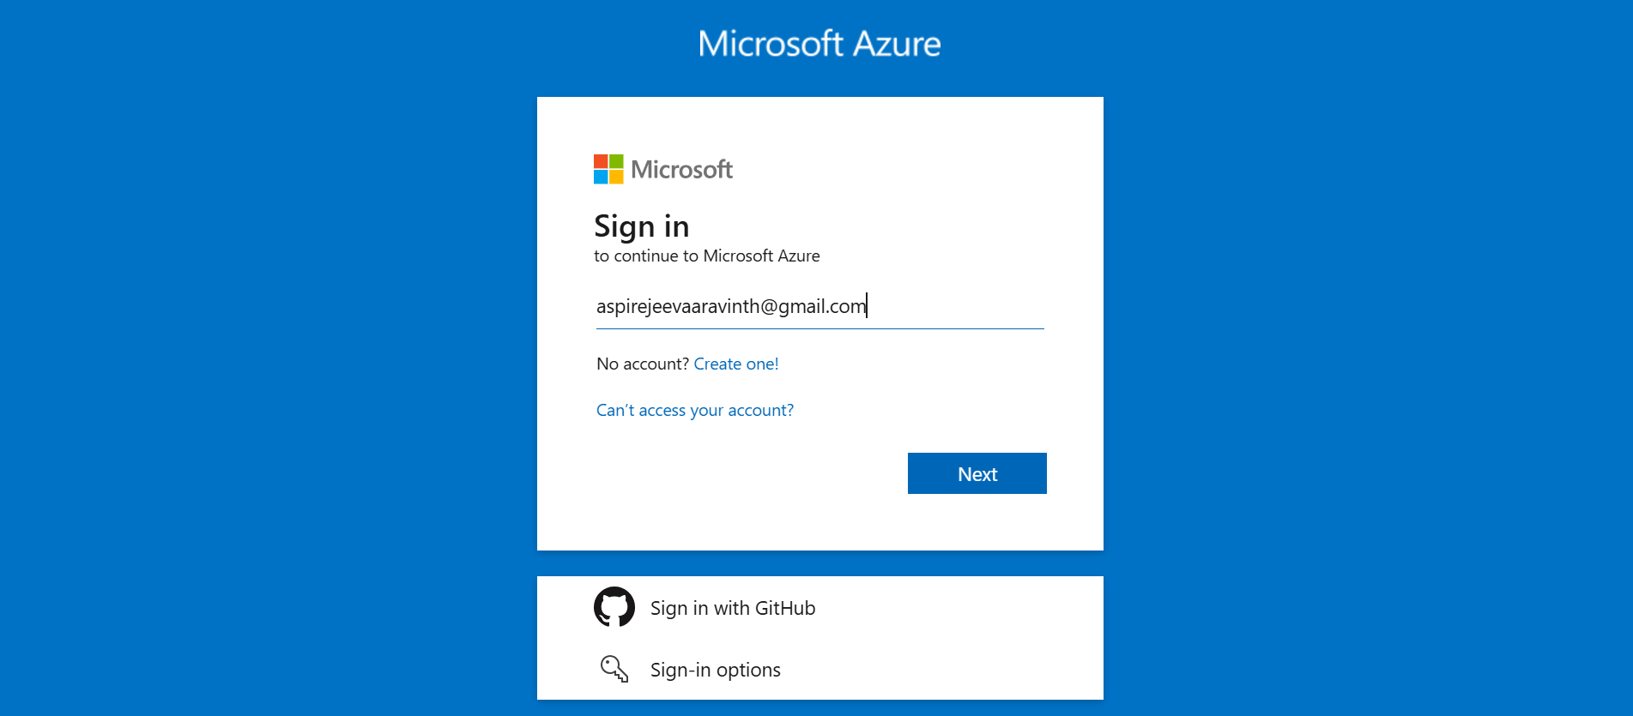

**STEP 3:** Sign up

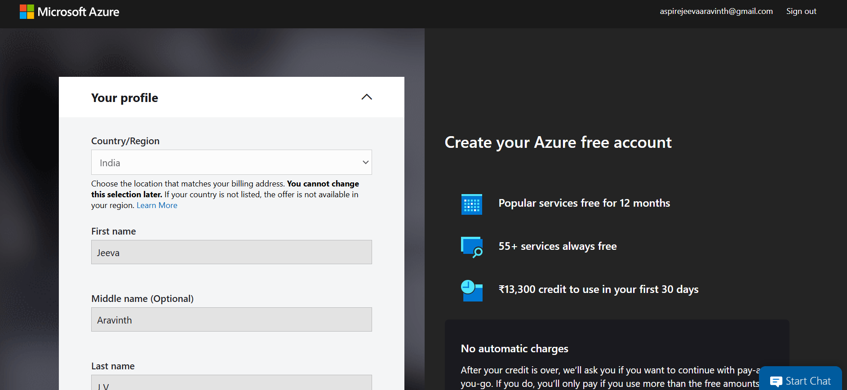

**STEP 4:** Subscription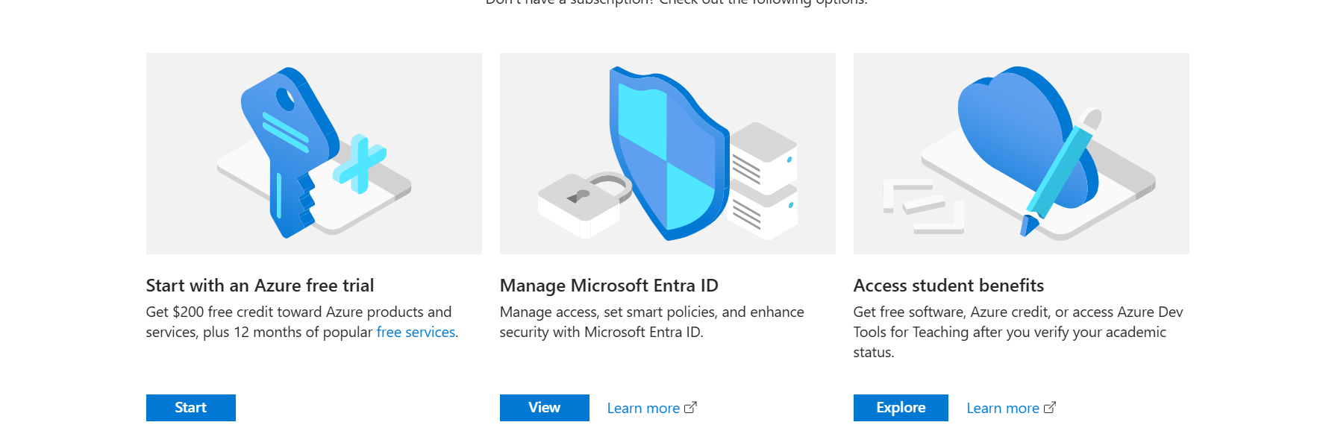

**STEP 5:** VM Machine

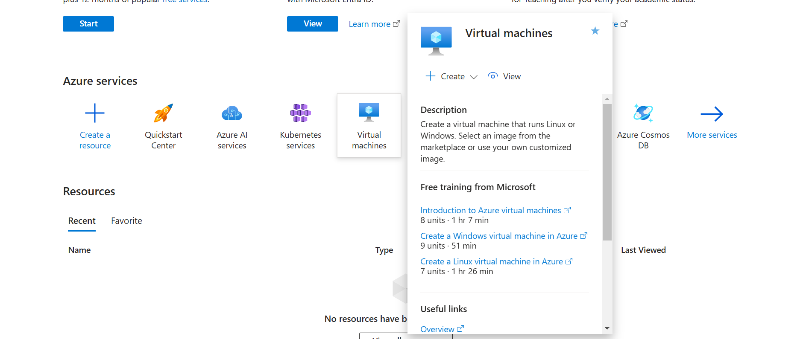

**STEP 6:** Virtual Machine to be created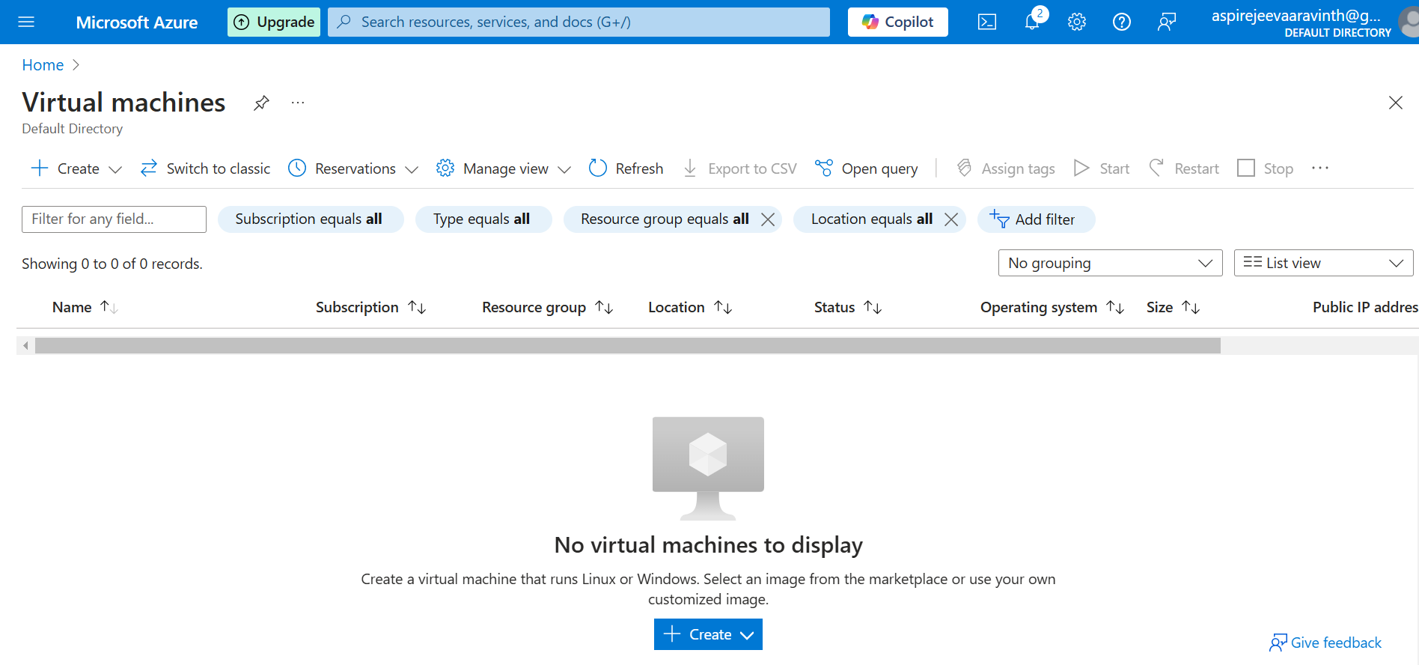**STEP 7:** Creating VM 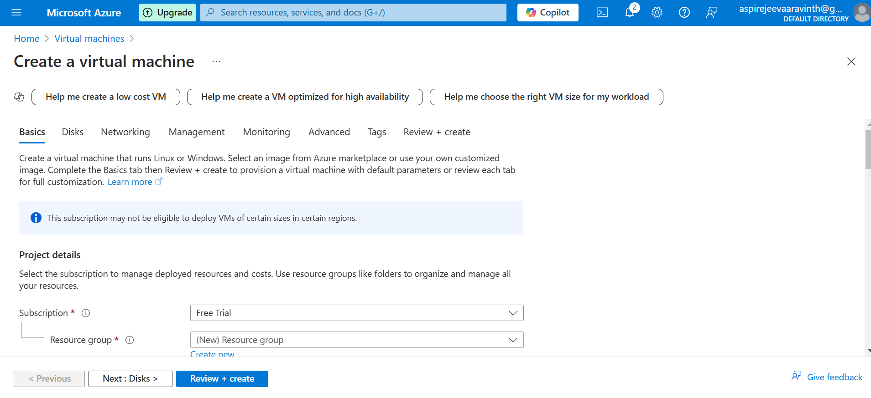**STEP 8:** VM Created

